CMR INSTITUTE OF TECHNOLOGY

Affiliated to Visvesvaraya Technological University (VTU)
Sri Nivasa Reddy Layout, AECS Layout, Marathahalli,
Bengaluru, Karnataka 560037



Department of Information Science and Engineering

LAB MANUAL

ANALYSIS & DESIGN OF ALGORITHMS LAB
(BCSL404)
Semester-IV
2025-2026
Scheme-2022

Sl.No | Experiments
1 | Design and implement C/C++ Program to find Minimum Cost Spanning Tree of a given connected undirected graph using Kruskal's algorithm.
2 | Design and implement C/C++ Program to find Minimum Cost Spanning Tree of a given connected undirected graph using Prim's algorithm.
3 | - Design and implement C/C++ Program to solve All-Pairs Shortest Paths problem using Floyd's algorithm.  - Design and implement C/C++ Program to find the transitive closure using Warshal's  algorithm.
4 | Design and implement C/C++ Program to find shortest paths from a given vertex in a weighted  connected graph to other vertices using Dijkstra's algorithm.
5 | Design and implement C/C++ Program to obtain the Topological ordering of vertices in a given digraph.
6 | Design and implement C/C++ Program to solve 0/1 Knapsack problem using Dynamic  Programming method.
7 | Design and implement C/C++ Program to solve discrete Knapsack and continuous Knapsack  problems using greedy approximation method.
8 | Design and implement C/C++ Program to find a subset of a given set S = {sl , s2,.....,sn} of n  positive integers whose sum is equal to a given positive integer d.
9 | Design and implement C/C++ Program to sort a given set of n integer elements using Selection Sort method and compute its time complexity. Run the program for varied values of n> 5000 and record the time taken to sort. Plot a graph of the time taken versus n. The elements can be read from a file or can be generated using the random number generator.
10 | Design and implement C/C++ Program to sort a given set of n integer elements using Quick Sort method and compute its time complexity. Run the program for varied values of n> 5000 and record the time taken to sort. Plot a graph of the time taken versus n. The elements can be read from a file or can be generated using the random number generator.
11 | Design and implement C/C++ Program to sort a given set of n integer elements using Merge Sort method and compute its time complexity. Run the program for varied values of n> 5000, and record the time taken to sort. Plot a graph of the time taken versus n. The elements can be read from a file or can be generated using the random number generator.
12 | Design and implement C/C++ Program for N Queen's problem using Backtracking.

1.Design and implement C/C++ Program to find Minimum Cost Spanning Tree of a given connected undirected graph using Kruskal's algorithm.

#include<stdio.h>
#include<conio.h>
#include<stdlib.h>
int i,j,k,a,b,u,v,n,ne=1;
int min,mincost=0,cost[9][9],parent[9];
int find(int);
int uni(int,int);
void main()
{
clrscr();
printf("\n\n\tImplementation of Kruskal's algorithm\n\n");
printf("\nEnter the no. of vertices\n");
scanf("%d",&n);
printf("\nEnter the cost adjacency matrix\n");
for(i=1;i<=n;i++)
{
for(j=1;j<=n;j++)
{
scanf("%d",&cost[i][j]);
if(cost[i][j]==0)
cost[i][j]=999;
}
}
printf("\nThe edges of Minimum Cost Spanning Tree are\n\n");
while(ne<n)
{
for(i=1,min=999;i<=n;i++)
{
for(j=1;j<=n;j++)
{
if(cost[i][j]<min)
{
min=cost[i][j];
a=u=i;
b=v=j;
}
}
}
u=find(u);
v=find(v);
if(uni(u,v))
{
printf("\n%d edge (%d,%d) =%d\n",ne++,a,b,min);
mincost +=min;
}
cost[a][b]=cost[b][a]=999;
}
printf("\n\tMinimum cost = %d\n",mincost);
getch();
}
int find(int i)
{
while(parent[i])
i=parent[i];
return i;
}
int uni(int i,int j)
{
if(i!=j)
{
parent[j]=i;
return 1;
}
return 0;
}

Output:
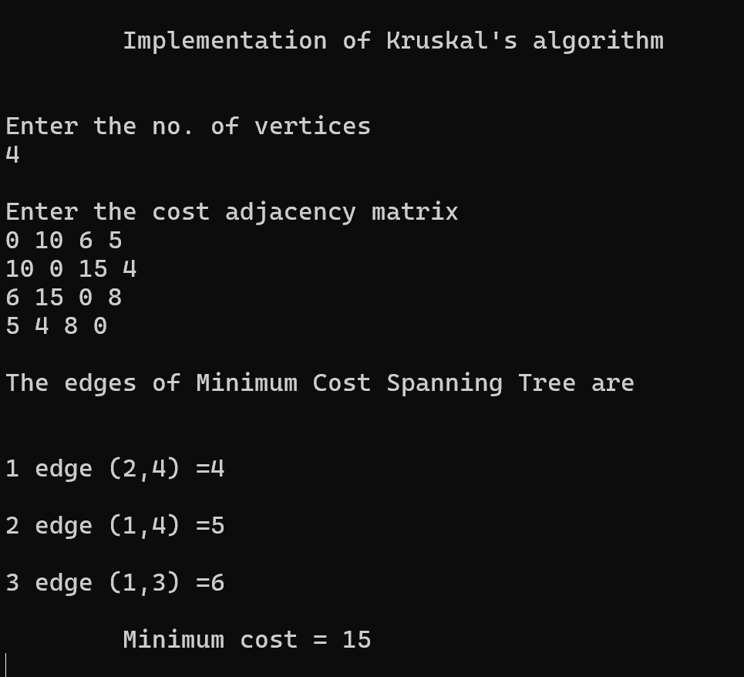

2.Design and implement C/C++ Program to find Minimum Cost Spanning Tree of a given connected undirected graph using Prim's algorithm.

#include <stdio.h>
#define MAX 10
#define INF 99999
int G[MAX][MAX] = {
{0, 19, 8},
{19, 0, 13},
{8, 13, 0}
};
int main() {
int n = 3;
int visited[MAX] = {0};
int min_cost = 0;
int i, j, u = 0, v;
int edges = 0;
visited[0] = 1; // start from vertex 0
printf("Edges in Spanning Tree:\n");
while (edges < n - 1) {
int min = INF;
for (i = 0; i < n; i++) {
if (visited[i]) {
for (j = 0; j < n; j++) {
if (!visited[j] && G[i][j] != 0 && G[i][j] < min) {
min = G[i][j];
u = i;
v = j;
}
}
}
}
printf("%d - %d : %d\n", u, v, min);
min_cost += min;
visited[v] = 1;
edges++;
}
printf("Minimum Cost = %d\n", min_cost);
return 0;
}
Output:
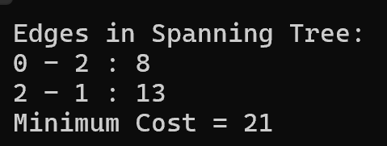

3.a. Design and implement C/C++ Program to solve All-Pairs Shortest Paths problem using Floyd's algorithm.

#include <stdio.h>
#define V 4
#define INF 9999

void printMatrix(int matrix[V][V]);

// Implementing Floyd–Warshall algorithm
void floydWarshall(int graph[V][V])
{
int matrix[V][V];
int i, j, k;

// Copy graph to matrix
for (i = 0; i < V; i++)
{
for (j = 0; j < V; j++)
{
matrix[i][j] = graph[i][j];
}
}

// Finding shortest paths
for (k = 0; k < V; k++)
{
for (i = 0; i < V; i++)
{
for (j = 0; j < V; j++)
{
if (matrix[i][k] + matrix[k][j] < matrix[i][j])
{
matrix[i][j] = matrix[i][k] + matrix[k][j];
}
}
}
}

printMatrix(matrix);
}

void printMatrix(int matrix[V][V])
{
int i, j;

for (i = 0; i < V; i++)
{
for (j = 0; j < V; j++)
{
if (i == j)
{
continue;
}
else if (matrix[i][j] == INF)
{
printf("No path exists between %d and %d\n", i, j);
}
else
{
printf("Shortest path from %d to %d is %d\n", i, j, matrix[i][j]);
}
}
}
}

int main()
{
int graph[V][V] = {
{0, INF, -3, INF},
{5, 0, 4, INF},
{INF, INF, 0, 3},
{INF, -2, INF, 0}
};

floydWarshall(graph);
return 0;
}
Output:

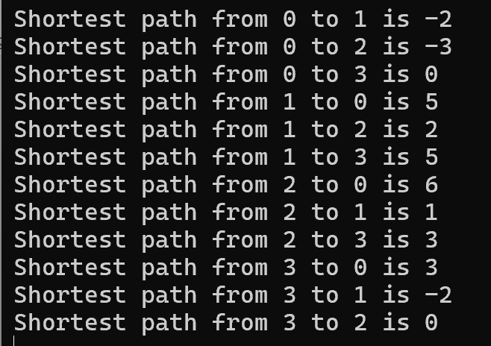

3.b. Design and implement C/C++ Program to find the transitive closure using Warshal's algorithm.

# include <stdio.h>
# include <conio.h>
int n,a[10][10],p[10][10];
void path()
{
int i,j,k;
for(i=0;i<n;i++)
for(j=0;j<n;j++)
p[i][j]=a[i][j];
for(k=0;k<n;k++)
for(i=0;i<n;i++)
for(j=0;j<n;j++)
if(p[i][k]==1&&p[k][j]==1) p[i][j]=1;
}
void main()
{
int i,j;
clrscr();
printf("Enter the number of nodes:");
scanf("%d",&n);
printf("\nEnter the adjacency matrix:\n");
for(i=0;i<n;i++)
for(j=0;j<n;j++)
scanf("%d",&a[i][j]);
path();
printf("\nThe path matrix is showm below\n");
for(i=0;i<n;i++)
{
for(j=0;j<n;j++)
printf("%d ",p[i][j]);
printf("\n");
}
getch();
}
Output:

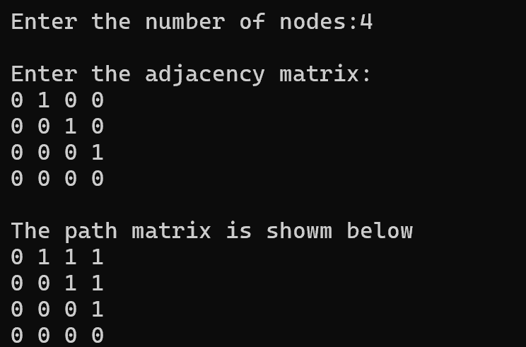
4.Design and implement C/C++ Program to find shortest paths from a given vertex in a weighted connected graph to other vertices using Dijkstra's algorithm.

#include <stdio.h>
#include <stdbool.h>
#define INF 99999
#define V 5 // Number of vertices

// A function to find the vertex with the minimum distance value, from the set of vertices not yet included in shortest path tree
int minDistance(int dist[], bool sptSet[]) {
int min = INF, min_index;

for (int v = 0; v < V; v++)
if (sptSet[v] == false && dist[v] <= min)
min = dist[v], min_index = v;

return min_index;
}

// A utility function to print the constructed distance array
void printSolution(int dist[]) {
printf("Vertex \t\t Distance from Source\n");
for (int i = 0; i < V; i++)
printf("%d \t\t %d\n", i, dist[i]);
}

// Dijkstra's algorithm for adjacency matrix representation of the graph
void dijkstra(int graph[V][V], int src) {
int dist[V]; // The output array. dist[i] will hold the shortest distance from src to i
bool sptSet[V]; // sptSet[i] will be true if vertex i is included in shortest path tree

// Initialize all distances as INFINITE and sptSet[] as false
for (int i = 0; i < V; i++)
dist[i] = INF, sptSet[i] = false;
dist[src] = 0;
// Find shortest path for all vertices
for (int count = 0; count < V - 1; count++) {
int u = minDistance(dist, sptSet);
sptSet[u] = true;
for (int v = 0; v < V; v++)
if (!sptSet[v] && graph[u][v] && dist[u] != INF && dist[u] + graph[u][v] < dist[v])
dist[v] = dist[u] + graph[u][v];
}

printSolution(dist);
}
// Driver code
int main() {
int graph[V][V] = {{0, 9, 6, 5, 3},
{9, 0, 0, 0, 0},
{6, 0, 0, 0, 0},
{5, 0, 0, 0, 0},
{3, 0, 0, 0, 0}};

dijkstra(graph, 0);
return 0;
}

Output:

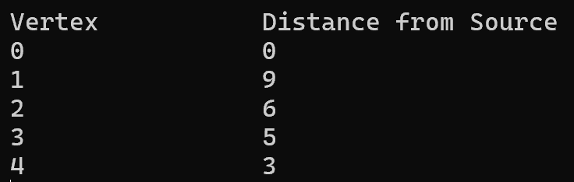
5.Design and implement C/C++ Program to obtain the Topological ordering of vertices in a given digraph.

#include <stdio.h>
#define MAX 10
int a[MAX][MAX], n, indegre[MAX];
// Function to calculate in-degrees of all vertices
void find_indegre() {
int i, j, sum;
for (j = 0; j < n; j++) {
sum = 0;
for (i = 0; i < n; i++) {
sum += a[i][j];
}
indegre[j] = sum;
}
}

// Function to perform topological sorting
void topology() {
int i, u, v, t[MAX], s[MAX], top = -1, k = 0;

// Find initial in-degrees
find_indegre();

// Push all vertices with in-degree 0 to stack
for (i = 0; i < n; i++) {
if (indegre[i] == 0) {
s[++top] = i;
}
}

// Process vertices from the stack
while (top != -1) {
u = s[top--];
t[k++] = u;

// Decrease the in-degree of all adjacent vertices
for (v = 0; v < n; v++) {
if (a[u][v] == 1) {
indegre[v]--;
if (indegre[v] == 0) {
s[++top] = v;
}
}
}
}

// Print the topological sequence
printf("The topological sequence is:\n");
for (i = 0; i < k; i++) {
printf("%d ", t[i]);
}
printf("\n");
}

int main() {
int i, j;
// Input the number of jobs (vertices)
printf("Enter number of jobs: ");
scanf("%d", &n);
// Input the adjacency matrix
printf("\nEnter the adjacency matrix:\n");
for (i = 0; i < n; i++) {
for (j = 0; j < n; j++) {
scanf("%d", &a[i][j]);
}
}
// Perform topological sorting
topology();
return 0;
}

Output:

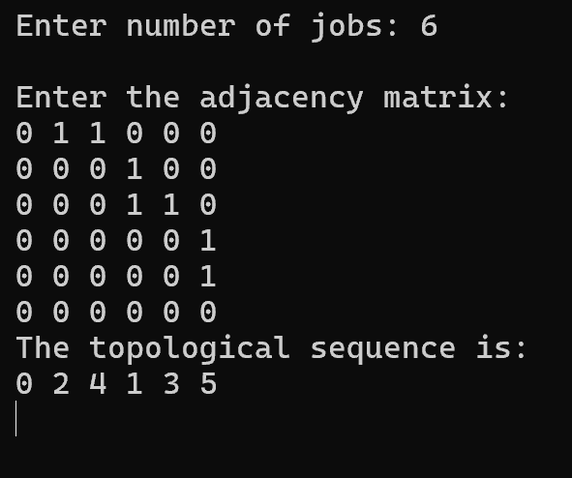

6. Design and implement C/C++ Program to solve 0/1 Knapsack problem using Dynamic Programming method.

#include<stdio.h>
#include<conio.h>
int w[10],p[10],v[10][10],n,i,j,cap,x[10]={0};
int max(int i,int j)
{
return ((i>j)?i:j);
}
int knap(int i,int j)
{
int value;
if(v[i][j]<0)
{
if(j<w[i])
value=knap(i-1,j);
else
value=max(knap(i-1,j),p[i]+knap(i-1,j-w[i]));
v[i][j]=value;
}
return(v[i][j]);
}
void main()
{
int profit,count=0;
clrscr();
printf("\nEnter the number of elements\n");
scanf("%d",&n);
printf("Enter the profit and weights of the elements\n");
for(i=1;i<=n;i++)
{
printf("For item no %d\n",i);
scanf("%d%d",&p[i],&w[i]);
}
printf("\nEnter the capacity \n");
scanf("%d",&cap);
for(i=0;i<=n;i++)
for(j=0;j<=cap;j++)
if((i==0)||(j==0))
v[i][j]=0;
else
v[i][j]=-1;
profit=knap(n,cap);
i=n;
j=cap;
while(j!=0&&i!=0)
{
if(v[i][j]!=v[i-1][j])
{
x[i]=1;
j=j-w[i];
i--;
}
else
i--;
}
printf("Items included are\n");
printf("Sl.no\tweight\tprofit\n");
for(i=1;i<=n;i++)
if(x[i])
printf("%d\t%d\t%d\n",++count,w[i],p[i]);
printf("Total profit = %d\n",profit);
getch();
}

Output:

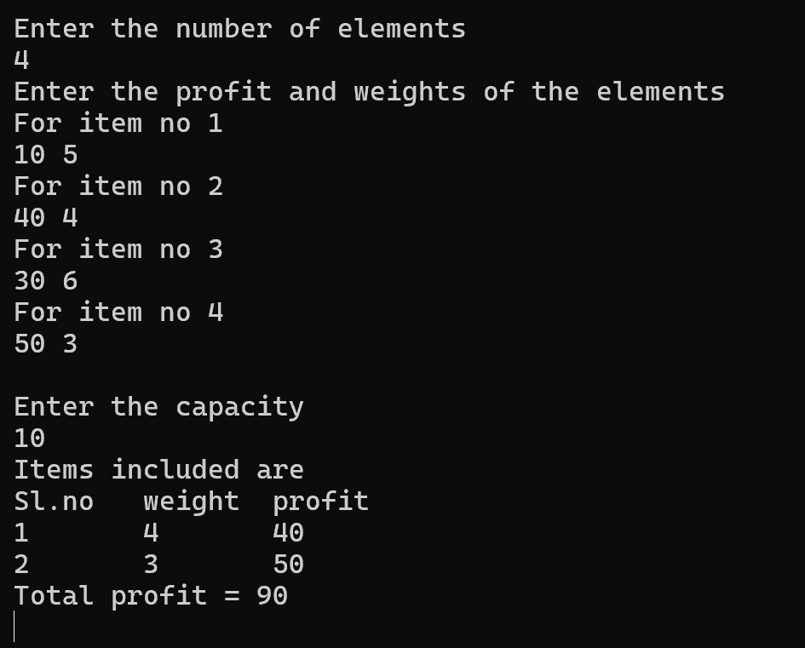

7.Design and implement C/C++ Program to solve discrete Knapsack and continuous Knapsack problems using greedy approximation method.

#include<stdio.h>
int main()
{
float weight[50],profit[50],ratio[50],Totalvalue,temp,capacity,amount;
int n,i,j;
printf("Enter the number of items :");
scanf("%d",&n);
for (i = 0; i < n; i++)
{
printf("Enter Weight and Profit for item[%d] :\n",i);
scanf("%f %f", &weight[i], &profit[i]);
}
printf("Enter the capacity of knapsack :\n");
scanf("%f",&capacity);

for(i=0;i<n;i++)
ratio[i]=profit[i]/weight[i];

for (i = 0; i < n; i++)
for (j = i + 1; j < n; j++)
if (ratio[i] < ratio[j])
{
temp = ratio[j];
ratio[j] = ratio[i];
ratio[i] = temp;

temp = weight[j];
weight[j] = weight[i];
weight[i] = temp;

temp = profit[j];
profit[j] = profit[i];
profit[i] = temp;
}

printf("Knapsack problems using Greedy Algorithm:\n");
for (i = 0; i < n; i++)
{
if (weight[i] > capacity)
break;
else
{
Totalvalue = Totalvalue + profit[i];
capacity = capacity - weight[i];
}
}
if (i < n)
Totalvalue = Totalvalue + (ratio[i]*capacity);
printf("\nThe maximum value is :%f\n",Totalvalue);
return 0;
}

Output:

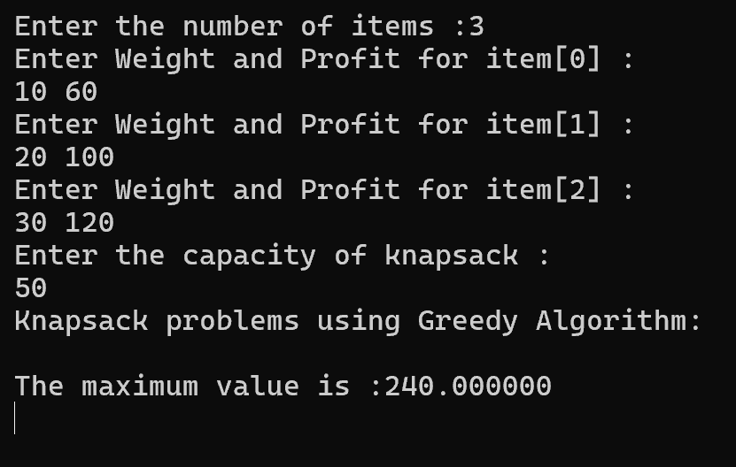
8. Design and implement C/C++ Program to find a subset of a given set S = {sl , s2,.....,sn} of n positive integers whose sum is equal to a given positive integer d.

#include <stdio.h>
int main() {
int n = 5;
// weight[i] = weight of item i
int weight[10] = {3, 3, 2, 5, 1};
// value[i] = value (profit) of item i
int value[10] = {10, 15, 10, 12, 8};
int capacity = 10; // Total knapsack capacity
int remaining_capacity;
float total_value = 0; // MUST initialize
int i, best_item;
// Track whether item is already selected
int selected[10];
for (i = 0; i < n; i++)
selected[i] = 0;
remaining_capacity = capacity;
while (remaining_capacity > 0) {
best_item = -1;
// Find item with maximum value/weight ratio
for (i = 0; i < n; i++) {
if (selected[i] == 0) {
if (best_item == -1 ||
(float)value[i] / weight[i] > (float)value[best_item] / weight[best_item]) {
best_item = i;
}
}
}
selected[best_item] = 1;

// Take the item
remaining_capacity -= weight[best_item];
if (remaining_capacity >= 0) {
// Take full item
total_value += value[best_item];
printf("Added item %d (value=%d, weight=%d) completely. Remaining capacity = %d\n",
best_item + 1, value[best_item], weight[best_item], remaining_capacity);
} else {
// Take fractional part
float fraction = (float)(remaining_capacity + weight[best_item]) / weight[best_item];
total_value += fraction * value[best_item];
printf("Added %.2f fraction of item %d (value=%d, weight=%d)\n",
fraction, best_item + 1, value[best_item], weight[best_item]);
break; // Knapsack is full
}
}
printf("\nTotal value in knapsack = %.2f\n", total_value);
return 0;
}
Output:

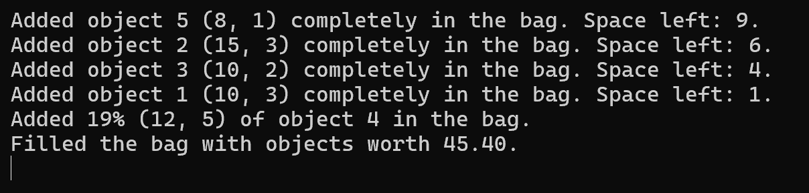

9. Design and implement C/C++ Program to sort a given set of n integer elements using Selection Sort method and compute its time complexity. Run the program for varied values of n> 5000 and record the time taken to sort. Plot a graph of the time taken versus n. The elements can be read
from a file or can be generated using the random number generator.

#include <stdio.h>
#include <stdlib.h>
#include <time.h>

int main()
{
int a[10000], i, j, temp, num;
clock_t st, et;

printf("Enter the number to give\n");
scanf("%d", &num);

for (i = 0; i < num; i++)
{
a[i] = rand() % 10000;
}

printf("Array before sorting\n");
for (i = 0; i < num; i++)
{
printf("%d\t", a[i]);
}

st = clock();
for (i = 0; i < num - 1; i++)
{
int min = i;
for (j = i + 1; j < num; j++)
{
if (a[j] < a[min])
{
min = j;
}
}
if (min != i)
{
temp = a[i];
a[i] = a[min];
a[min] = temp;
}
}
et = clock();

printf("\nSelection Sort in C\n");
for (i = 0; i < num; i++)
{
printf("a[%d] = %d\n", i, a[i]);
}

printf("Time taken : %f seconds\n",
(double)(et - st) / CLOCKS_PER_SEC);

return 0;
}

Output:

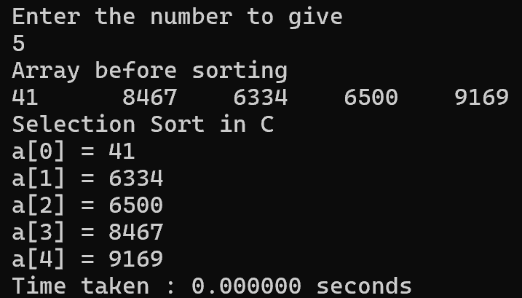

10.Design and implement C/C++ Program to sort a given set of n integer elements using Quick Sort method and compute its time complexity. Run the program for varied values of n> 5000 and record the time taken to sort. Plot a graph of the time taken versus n. The elements can be read
from a file or can be generated using the random number generator.

# include <stdio.h>
# include <stdlib.h>
# include <time.h>

/* function that consider last element as pivot, place the pivot at its exact position, and place smaller elements to left of pivot and greater elements to right of pivot. */
int partition (int a[], int start, int end)
{
int pivot = a[end]; // pivot element
int i = (start - 1);

for (int j = start; j <= end - 1; j++)
{
// If current element is smaller than the pivot
if (a[j] < pivot)
{
i++; // increment index of smaller element
int t = a[i];
a[i] = a[j];
a[j] = t;
}
}
int t = a[i+1];
a[i+1] = a[end];
a[end] = t;
return (i + 1);
}

/* function to implement quick sort */
void quick(int a[], int start, int end) /* a[] = array to be sorted, start = Starting index, end = Ending index */
{
if (start < end)
{
int p = partition(a, start, end); //p is the partitioning index
quick(a, start, p - 1);
quick(a, p + 1, end);
}
}

/* function to print an array */
void printArr(int a[], int n)
{
int i;
for (i = 0; i < n; i++)
printf("%d ", a[i]);
}
int main()
{
int n, a[1000],k;
clock_t st,et;
double ts;
printf("\n Enter How many Numbers: ");
scanf("%d", &n);
printf("\nThe Random Numbers are:\n");
for(k=0; k<n; k++)
{
a[k]=rand();
printf("%d\t",a[k]);
}
st=clock();
printf("\nBefore sorting array elements are - \n");
printArr(a, n);
quick(a, 0, n - 1);
printf("\nAfter sorting array elements are - \n");
printArr(a, n);
et=clock();
ts=(double)(et-st)/CLOCKS_PER_SEC;
printf("\nSorted Numbers are: \n ");
for(k=0; k<n; k++)
printf("%d\t", a[k]);
printf("\nThe time taken is %e",ts);
return 0;
}

Output:

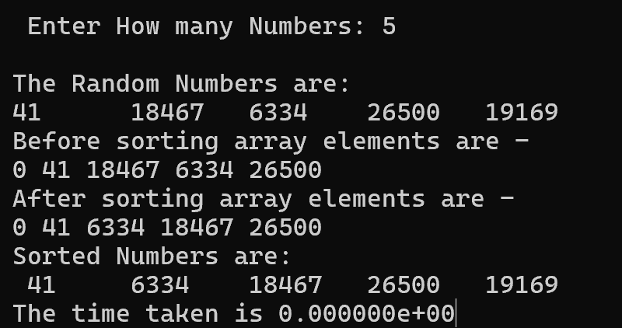

11. Design and implement C/C++ Program to sort a given set of n integer elements using Merge Sort method and compute its time complexity. Run the program for varied values of n> 5000, and record the time taken to sort. Plot a graph of the time taken versus n. The elements can be read from a file or can be generated using the random number generator.

#include <stdio.h>
#include <stdlib.h>
#include <time.h>

// Merge two subarrays of arr[]
// First subarray is arr[l..m]
// Second subarray is arr[m+1..r]
void merge(int arr[], int l, int m, int r) {
int i, j, k;
int n1 = m - l + 1;
int n2 = r - m;

// Create temporary arrays
int L[n1], R[n2];

// Copy data to temporary arrays L[] and R[]
for (i = 0; i < n1; i++)
L[i] = arr[l + i];
for (j = 0; j < n2; j++)
R[j] = arr[m + 1 + j];

// Merge the temporary arrays back into arr[l..r]
i = 0; // Initial index of first subarray
j = 0; // Initial index of second subarray
k = l; // Initial index of merged subarray
while (i < n1 && j < n2) {
if (L[i] <= R[j]) {
arr[k] = L[i];
i++;
} else {
arr[k] = R[j];
j++;
}
k++;
}

// Copy the remaining elements of L[], if any
while (i < n1) {
arr[k] = L[i];
i++;
k++;
}

// Copy the remaining elements of R[], if any
while (j < n2) {
arr[k] = R[j];
j++;
k++;
}
}

// Main function to perform merge sort
void mergeSort(int arr[], int l, int r) {
if (l < r) {
int m = l + (r - l) / 2;

// Sort first and second halves
mergeSort(arr, l, m);
mergeSort(arr, m + 1, r);

// Merge the sorted halves
merge(arr, l, m, r);
}
}

// Function to generate n random integers and store them in arr[]
void generateRandomNumbers(int arr[], int n) {
srand(time(NULL));
for (int i = 0; i < n; i++) {
arr[i] = rand() % 1000; // Generate random integers between 0 and 999
}
}

int main() {
FILE *fp;
fp = fopen("time_complexity_data.txt", "w");
if (fp == NULL) {
printf("Error opening file!\n");
exit(1);
}

int n_values[] = {5000, 10000, 15000, 20000}; // Change or add more values as needed
int num_values = sizeof(n_values) / sizeof(n_values[0]);

for (int i = 0; i < num_values; i++) {
int n = n_values[i];
int arr[n];

// Generate random numbers
generateRandomNumbers(arr, n);

// Record starting time
clock_t start_time = clock();

// Perform Merge Sort
mergeSort(arr, 0, n - 1);

// Record ending time
clock_t end_time = clock();

// Calculate the time taken
double time_taken = ((double)(end_time - start_time)) / CLOCKS_PER_SEC;

// Print the size of array and the time taken to sort
printf("n = %d, Time taken: %f seconds\n", n, time_taken);
fprintf(fp, "%d %f\n", n, time_taken);
}

fclose(fp);
return 0;
}

Output:

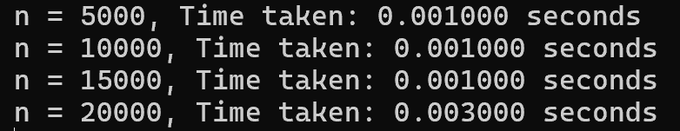

12.Design and implement C Program for N Queen's problem using Backtracking.

#include <stdio.h>
#include <stdbool.h>

#define N 8 // Define the size of the chessboard

// Function to print the solution
void printSolution(int board[N][N]) {
for (int i = 0; i < N; i++) {
for (int j = 0; j < N; j++)
printf("%d ", board[i][j]);
printf("\n");
}
}

// Function to check if a queen can be placed on board[row][col]
bool isSafe(int board[N][N], int row, int col) {
int i, j;

// Check this row on the left side
for (i = 0; i < col; i++)
if (board[row][i])
return false;

// Check upper diagonal on left side
for (i = row, j = col; i >= 0 && j >= 0; i--, j--)
if (board[i][j])
return false;

// Check lower diagonal on left side
for (i = row, j = col; j >= 0 && i < N; i++, j--)
if (board[i][j])
return false;

return true;
}

// Recursive function to solve N Queen problem
bool solveNQUtil(int board[N][N], int col) {
// Base case: If all queens are placed then return true
if (col >= N)
return true;

// Consider this column and try placing this queen in all rows one by one
for (int i = 0; i < N; i++) {
// Check if the queen can be placed on board[i][col]
if (isSafe(board, i, col)) {
// Place this queen in board[i][col]
board[i][col] = 1;

// Recur to place rest of the queens
if (solveNQUtil(board, col + 1))
return true;

// If placing queen in board[i][col] doesn't lead to a solution, then remove queen from board[i][col]
board[i][col] = 0; // Backtrack
}
}

// If the queen cannot be placed in any row in this column col, then return false
return false;
}

// Main function to solve N Queen problem
bool solveNQ() {
int board[N][N] = { {0, 0, 0, 0, 0, 0, 0, 0},
{0, 0, 0, 0, 0, 0, 0, 0},
{0, 0, 0, 0, 0, 0, 0, 0},
{0, 0, 0, 0, 0, 0, 0, 0},
{0, 0, 0, 0, 0, 0, 0, 0},
{0, 0, 0, 0, 0, 0, 0, 0},
{0, 0, 0, 0, 0, 0, 0, 0},
{0, 0, 0, 0, 0, 0, 0, 0} };

if (solveNQUtil(board, 0) == false) {
printf("Solution does not exist");
return false;
}

printSolution(board);
return true;
}

int main() {
solveNQ();
return 0;
}

Output:
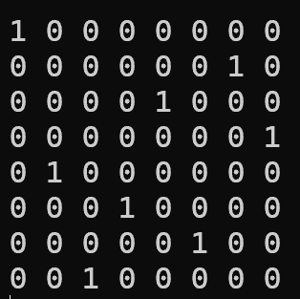
ADDITIONAL PROGRAMS
1.Find the binomial co-efficient using dynamic programming.

#include<stdio.h>
#include<conio.h>
long int bin(int n,int k)
{
int i,j;
long int arr[20][20];
for(i=0;i<=n;i++)
{
for(j=0;j<=(k<i?k:i);j++)
{
if(i==j||j==0)
{
arr[i][j]=1;
}
else
{
arr[i][j]=arr[i-1][j]+arr[i-1][j-1];
}
}
}
return(arr[n][k]);
}
void main()
{
int n,k;
clrscr();
printf("\nEnter the value of n ");
scanf("%d",&n);
printf("\nEnter the value of k ");
scanf("%d",&k);
if(n<0||k<0||k>n)
{
printf("\nValue cannot be calculated!!");
}
else
{
printf("\nThe binomial coefficient is %ld.",bin(n,k));
}
getch();
}

Output:

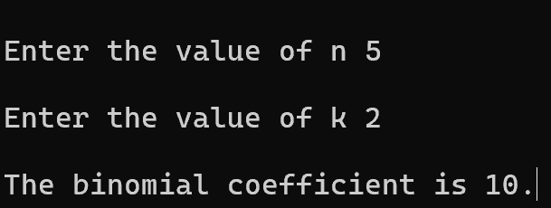

2.Find the minimum cost spanning tree of a given undirected graph using Prim's algorithm.

#include<stdio.h>
#include<conio.h>
void main()
{
int a[20][20],add[20],f[20][20],min,posx,posy,i,j,k,n,tot,flag=0,weight=0;
clrscr();
tot=0;
printf("\nEnter the value of n ");
scanf("%d",&n);
printf("\nEnter the adjacency matrix ");
for(i=0;i<n;i++)
{
add[i]=0;
for(j=0;j<n;j++)
{
scanf("%d",&a[i][j]);
f[i][j]=0;
}
}
add[0]=1;
while(flag==0)
{
flag=1;
min=9999;
for(i=0;i<n;i++)
{
if(add[i]==1)
{
for(j=0;j<n;j++)
{
if(add[j]==0&&a[i][j]!=0&&a[i][j]<min)
{
min=a[i][j];
posx=i;
posy=j;
}
}
}
}
if(min!=9999)
{
f[posx][posy]=min;
f[posy][posx]=min;
weight=weight+f[posx][posy];
tot++;
flag=0;
add[posx]=1;
add[posy]=1;
}
}
if(tot!=n-1)
{
printf("\nMinimum spannin does not exist!!");
}
else
{
printf("\nMinimum spanning tree with weight=%d is ",weight);
for(i=0;i<n;i++)
{
printf("\n");
for(j=0;j<n;j++)
{
printf("%d ",f[i][j]);
}
}
}
getch();
}

Output:

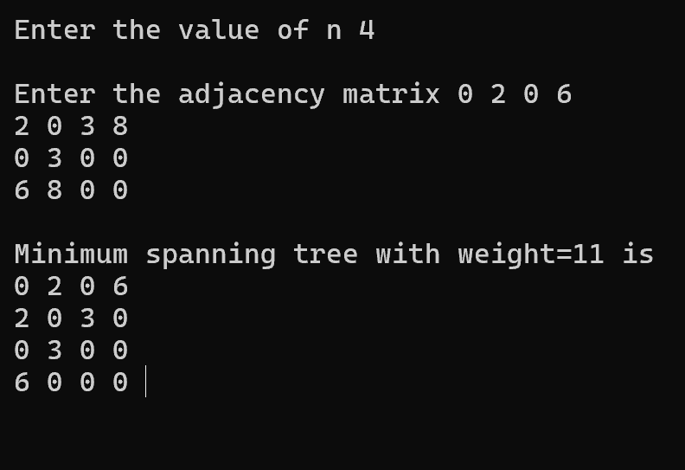

Viva Questions:

A. Graph Algorithms (Kruskal, Prim, Dijkstra, Floyd, Warshall, Topological Sort)
- What is the fundamental difference between Prim’s and Kruskal’s algorithms?
- Why does Kruskal’s algorithm require a disjoint-set (union–find) structure?
- Can Kruskal’s algorithm work on a disconnected graph? Justify.
- Why is cycle detection essential in Kruskal’s algorithm?
- In Prim’s algorithm, how does the choice of starting vertex affect the MST?
- Compare the time complexity of Prim’s algorithm using:
  - adjacency matrix
  - priority queue (heap)
- Why does Dijkstra’s algorithm fail when negative edge weights are present?
- How is Dijkstra’s algorithm different from Bellman–Ford?
- What problem does Floyd’s algorithm solve, and why is it classified as dynamic programming?
- State the time and space complexity of Floyd’s algorithm.
- What is the difference between Floyd’s algorithm and Warshall’s algorithm?
- What is meant by transitive closure of a graph?
- Why is topological sorting possible only for DAGs?
- Can a graph have more than one valid topological ordering? Explain with reason.
- How do you detect a cycle using topological sorting?

🔹 B. Dynamic Programming (0/1 Knapsack, Binomial Coefficient)
- What are the two key properties that make a problem suitable for dynamic programming?
- Differentiate between 0/1 knapsack and fractional knapsack.
- Why is 0/1 knapsack not solvable using a greedy approach?
- What does the DP table entry dp[i][w] represent in knapsack?
- Explain overlapping subproblems with respect to knapsack.
- Why is memoization called top-down DP?
- Compare recursive, memoized, and tabulated DP approaches.
- How is Pascal’s triangle related to the binomial coefficient DP?
- What is the time complexity of computing C(n, k) using DP?

🔹 C. Greedy Algorithms (Knapsack, MST)
- What is the greedy choice property?
- Why does fractional knapsack satisfy the greedy choice property?
- What is the sorting criterion used in fractional knapsack?
- Why does greedy fail for subset sum and 0/1 knapsack?
- Give two graph problems where greedy algorithms work optimally.
- Can greedy algorithms always guarantee optimal solutions? Why?

🔹 D. Sorting Algorithms & Time Complexity (Selection, Quick, Merge)
- Why is selection sort considered inefficient for large inputs?
- What is the best, average, and worst-case time complexity of quick sort?
- When does quick sort degrade to O(n²)?
- Why is merge sort preferred over quick sort in linked lists?
- Why is merge sort considered a stable sorting algorithm?
- Why is selection sort not adaptive?
- What is meant by in-place sorting? Which of your algorithms are in-place?
- Why do we plot time vs n graphs for sorting algorithms?

🔹 E. Backtracking & NP Concepts (Subset Sum, N-Queens)
- Why are subset sum and N-Queens solved using backtracking?
- Why are problems like subset sum classified as NP-Complete, and what does that imply?
- What is the state-space tree in backtracking, and how is it constructed?
- How does backtracking differ from brute force, even though both explore solution spaces?
- What is meant by pruning in backtracking, and why is it crucial for efficiency?
- In the N-Queens problem, what constraints are checked before placing a queen?
- What is the branching factor in backtracking, and how does it affect time complexity?
- Why is the worst-case time complexity of backtracking still exponential?
- How does backtracking ensure that all feasible solutions are explored?
- Compare backtracking and branch-and-bound in terms of search strategy.
- Why is recursion particularly suitable for backtracking algorithms?
- Can backtracking be converted into an iterative approach? If yes, how?

